

### TripAdvisor E-Management

**College**: 7155 - PSG Institute of Technology and Applied Research

**Team ID:** NM2024TMID00621

**Team Lead:** Suriya Sampathkumar (D1D35391C5E72E6995F4A4F9E021C474)

**Team Members:**

|  |  |
| --- | --- |
| Devadarshini M | 20F3289BE510861861D41E9D291D61C9 |
| Ramya A | CED35E837A249C183384073A9FC98513 |
| Renil Shaji | 5393AB9DFFECB9782D14BC338E46948E |
| Suriya Sampathkumar | D1D35391C5E72E6995F4A4F9E021C474 |
| Varshha D | 9CDCDC27EFB027899CC4E995C0D2EBD2 |

### 1. Project Overview

The **TripAdvisor E-Management app** integrates with the **Salesforce platform** to serve as an all-in-one travel companion. This app provides users with the ability to plan, book, and optimize their travel experience, while helping them discover millions of reviews, recommendations, and insights shared by fellow travellers. The application focuses on managing hotels, flights, and food options, making it easier for customers to make informed decisions and streamline their travel planning process. This system also helps businesses automate the data management process related to hotels, food options, and flight schedules while offering customers benefits such as personalized discounts and timely flight reminders.

### 

### 

### 2. Objectives

The primary goals of this project are:

1. **Data Management Efficiency**: Automate the data management processes for hotels, flights, and food options, reducing manual effort and errors.
2. **Personalized Customer Discounts**: Implement a discount system based on the customer’s spending, with tiered discount rates for specific spending thresholds.
3. **Timely Flight Reminders**: Automate the process of sending reminders to customers about their flight schedules 24 hours prior to departure.
4. **Real-Time Updates**: Ensure real-time updates to hotel data when food options are added or modified, maintaining accurate counts and availability.

### Business Goals:

1. **Simplify Operations**: Streamline the management of hotel data, flight schedules, and food options, saving time and minimizing errors.
2. **Enhance Customer Experience**: Provide a better customer experience through automatic discounts based on purchase amounts and timely notifications about upcoming flights.
3. **Automate Repetitive Tasks**: Replace manual processes with automated solutions that reduce the administrative burden and improve accuracy.
4. **Improve Data Integrity**: Maintain accurate data relationships across hotel, food, and flight records through Salesforce automation tools like Apex Triggers and Flows.

### Specific Outcomes:

1. **Automated Hotel and Food Option Management**: When food options are added or updated, the system will automatically update the corresponding hotel records, including recalculating the total count of available food options for each hotel.
2. **Customer Discount System**: A flow-based automation will calculate discounts based on the customer’s total purchase amount. Discounts are applied in tiers—full, partial, or none—depending on spending.
3. **Flight Schedule Reminders**: A scheduled job will send reminder emails to customers who have booked flights, ensuring they are aware of their flight timing 24 hours before departure.

### 3. Salesforce Key Features and Concepts Utilized

1. **Custom Objects**: Custom objects have been created for Hotels, Food Options, Customers, and Flights, each with specific fields that support business processes.
2. **Custom Fields**: Fields such as total food options, food amount, and departure times have been added to store and track relevant data for each object.
3. **Flows**: Flows are used to automate the discount process, triggering different actions based on the customer’s total purchase amount.
4. **Apex Triggers**: Triggers are used to update hotel information when food options are modified, ensuring that the hotel’s data stays consistent and up-to-date.
5. **Apex Schedulable Classes**: A scheduled class sends timely flight reminders to customers 24 hours before departure, improving customer engagement and reducing the likelihood of missed flights.

**4. Detailed Steps to Solution Design**

### Step 1: Setting Up the Salesforce Developer Account

Created a Salesforce Developer Account to access the development tools necessary for building and testing the application. This provided a controlled environment for implementing and refining features.

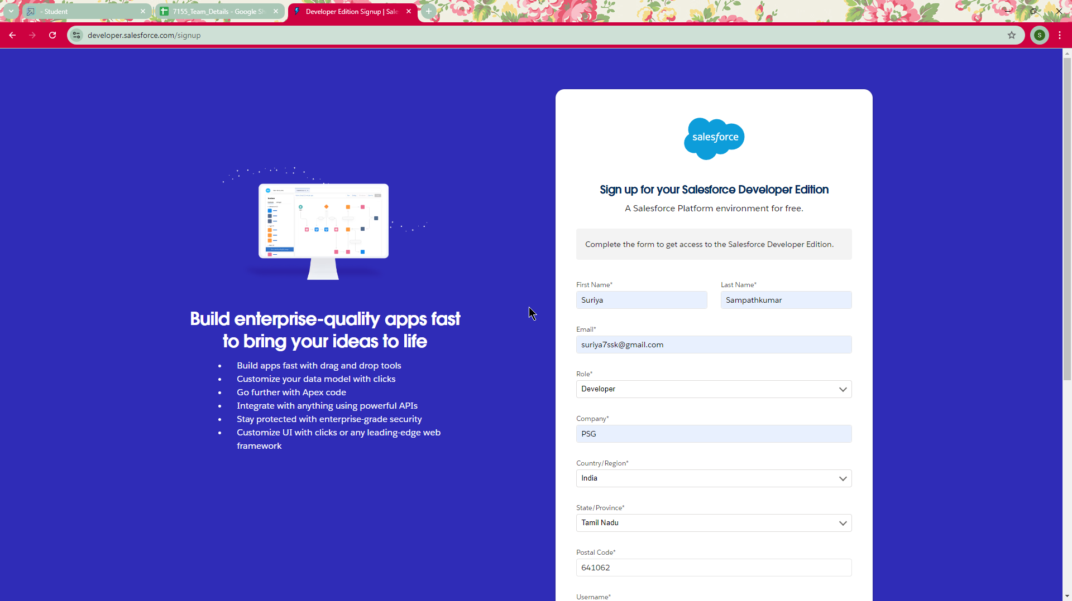

Creating developer account

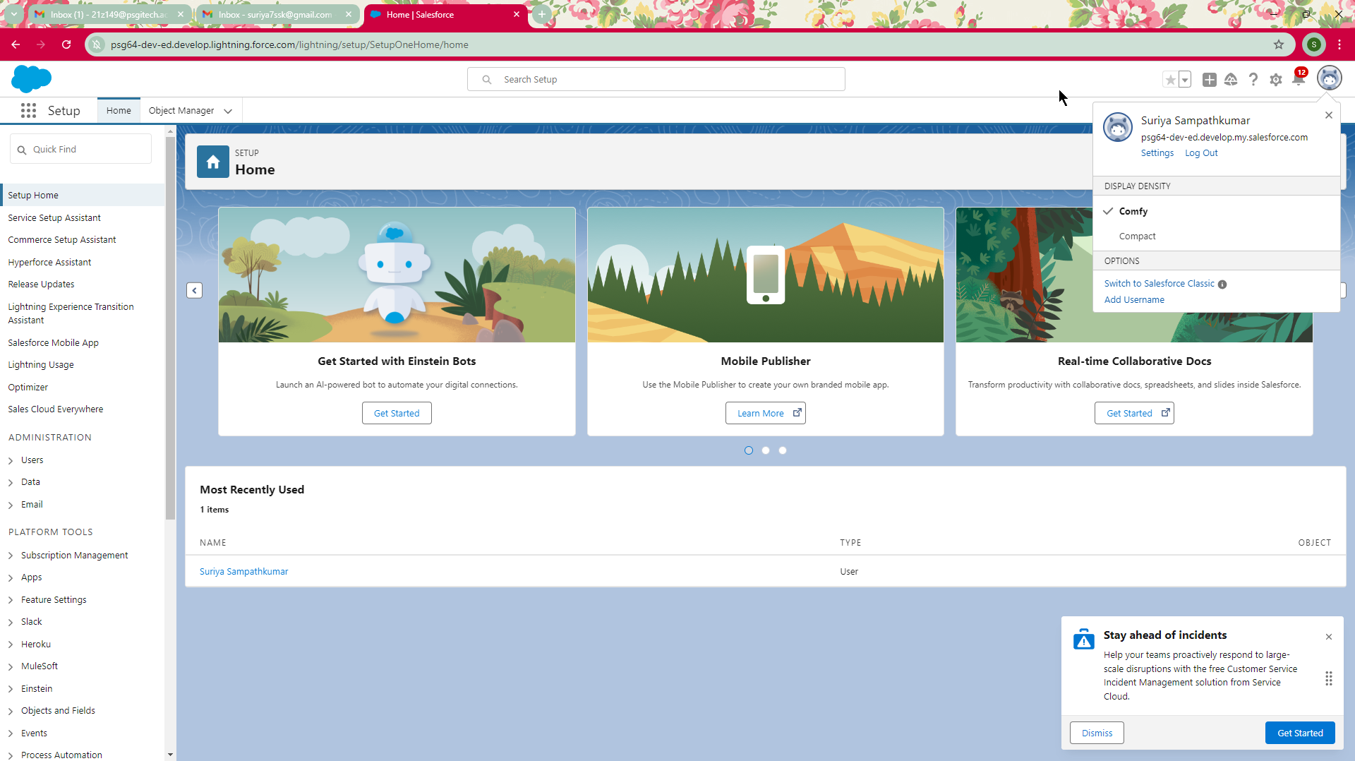

Account activation

### 

### Step 2: Defining Custom Objects

**Hotel Object**:

* **Fields**: Hotel Name (Text), Total Food Options (Number).
* **Purpose**: To store information about hotels and track the availability of meal options.

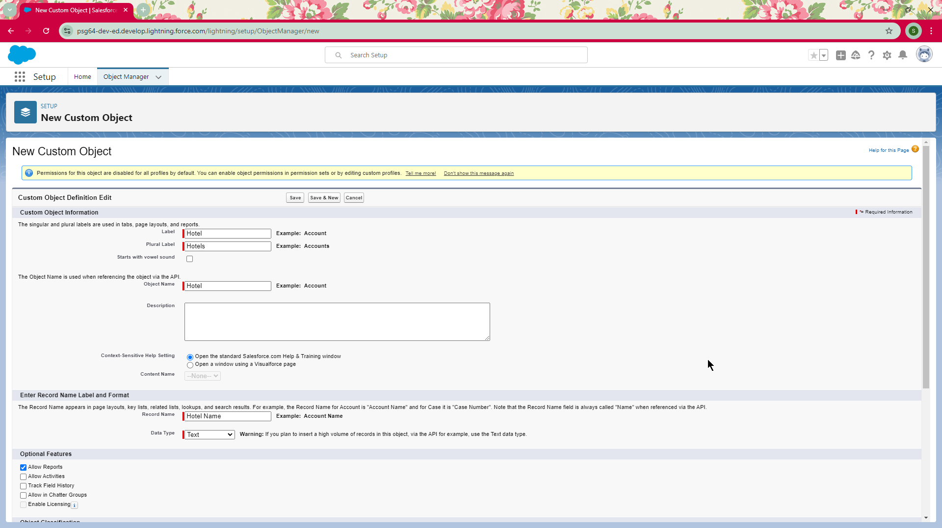

Creating object Hotel

**Food Option Object**:

* **Fields**: Name (Text), Hotel (Lookup), Food Amount (Currency).
* **Purpose**: To catalog food offerings associated with hotels.

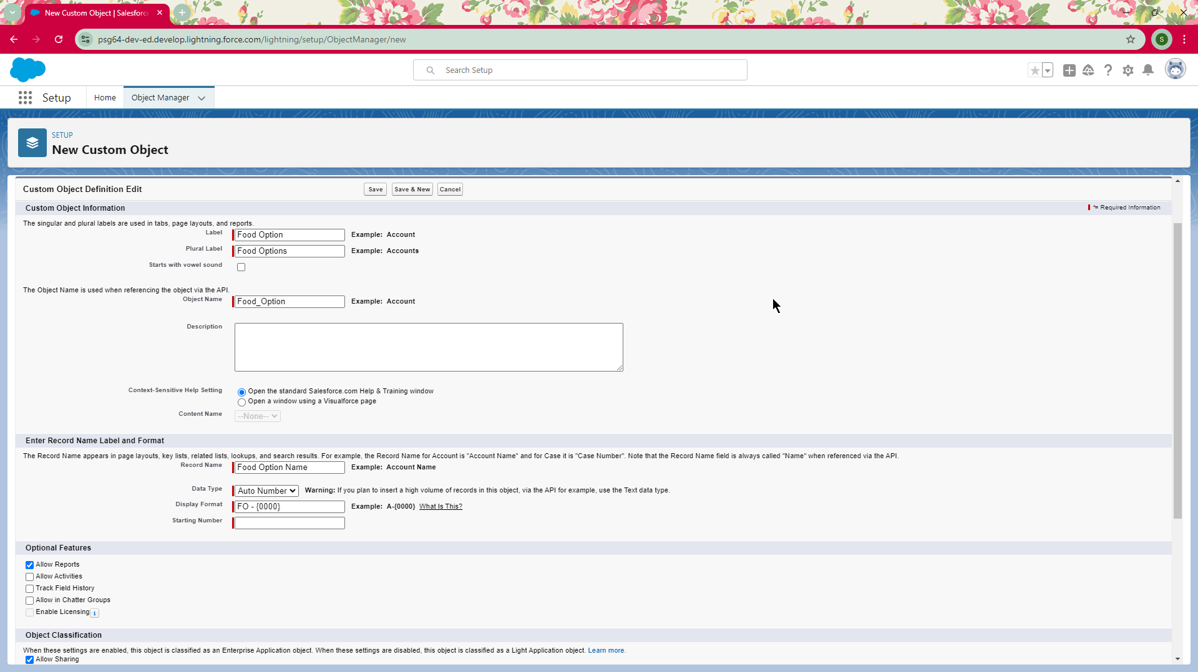

Creating object Food Option

**Flight Object**:

* **Fields**: DepartureDateTime (Date/Time), ContactEmail (Text).
* **Purpose**: To manage flight schedules and send reminders.

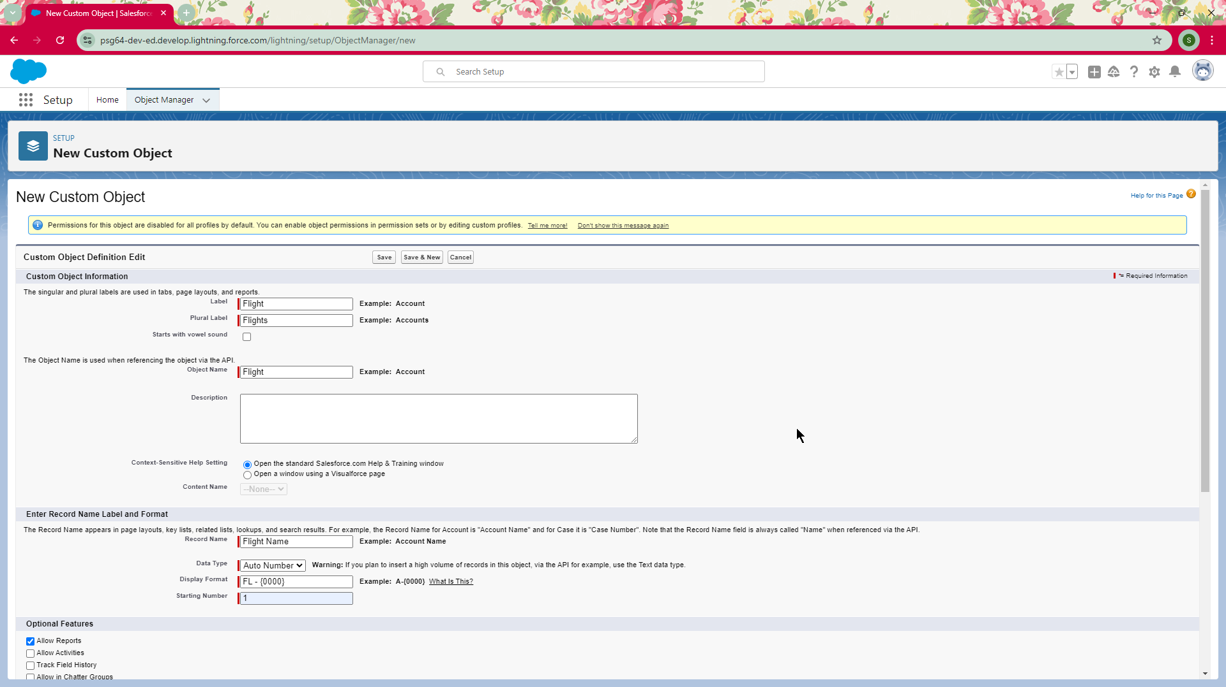

Creating object Flight

**Customer Object**:

* **Fields**: Name (Text), Total Spending (Currency), Discount (Percentage).
* **Purpose**: To track customer interactions and calculate eligible discounts.

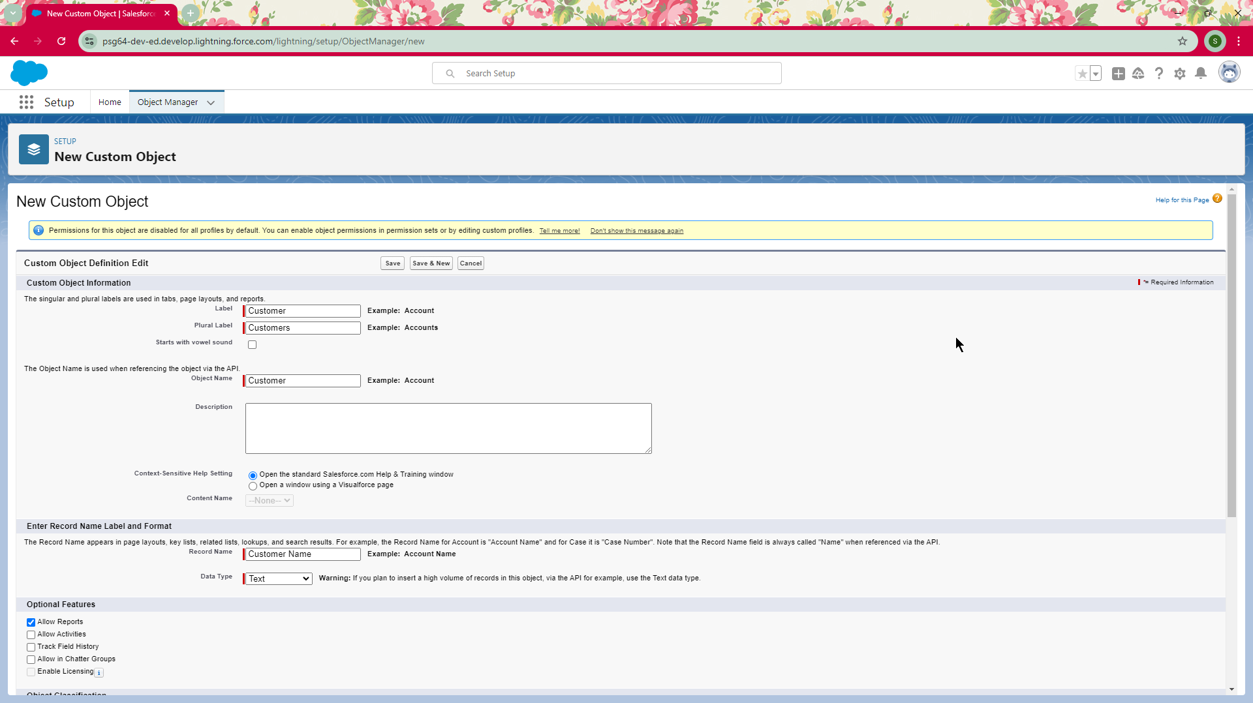

Creating object Customer

#### Step 3: Field Definitions

**Hotel Object Fields**:

* 1. **TotalFoodOptions** (Number): Tracks the total number of food options available at each hotel.
  2. **Date** (Date): The date of hotel information entry or update.

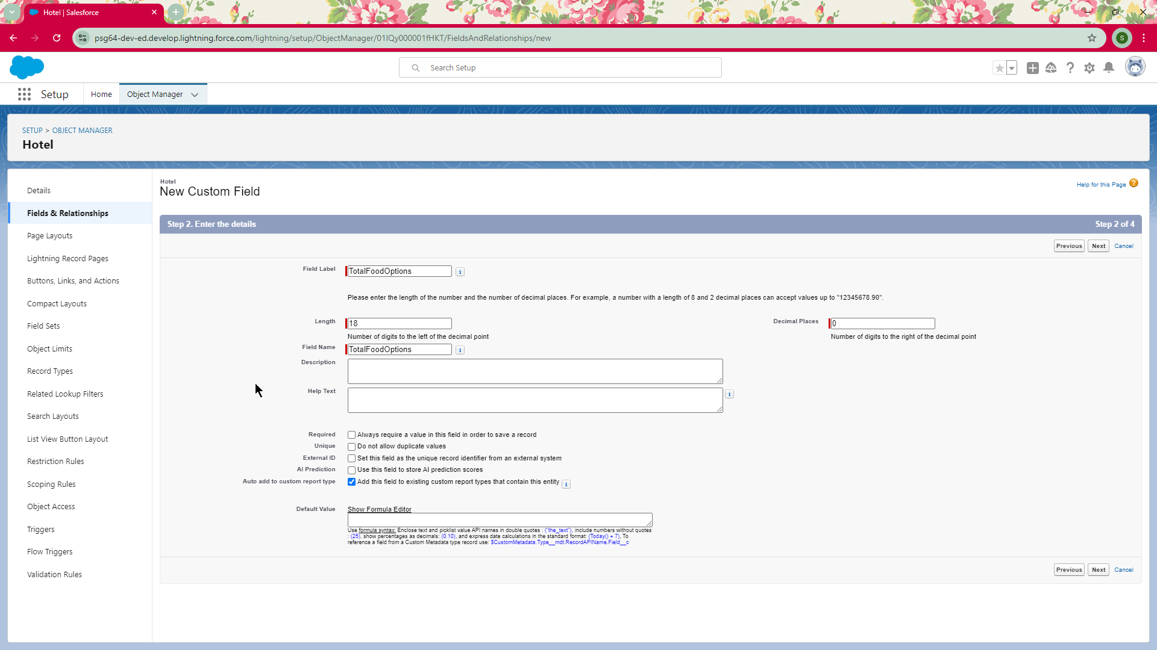

Creating field TotalFoodOptions

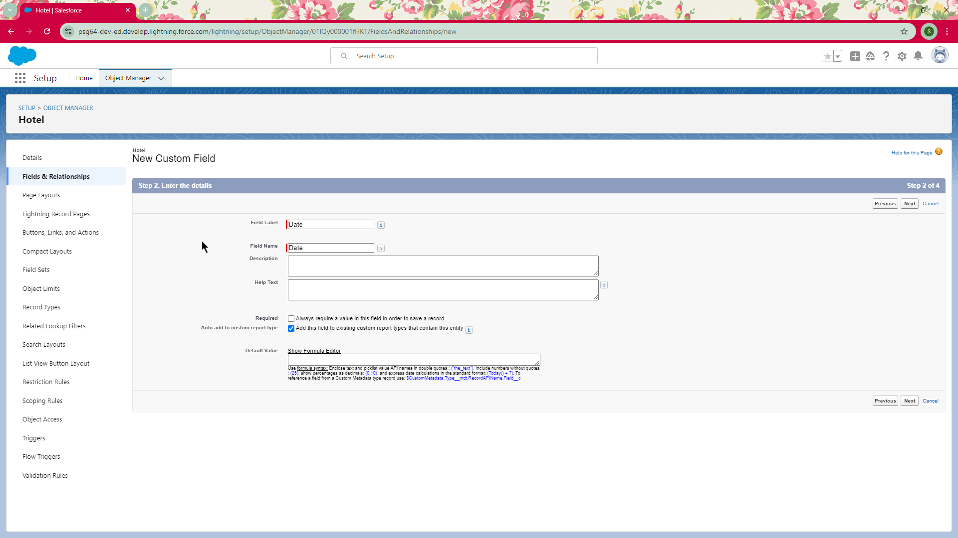

Creating field Date

**Food Option Fields:**

1. **Name (Text):** The name of the food option.
2. **Hotel (Lookup):** A lookup field linking each food option to the respective hotel.
3. **Food Amount (Currency):** The price of the food option.

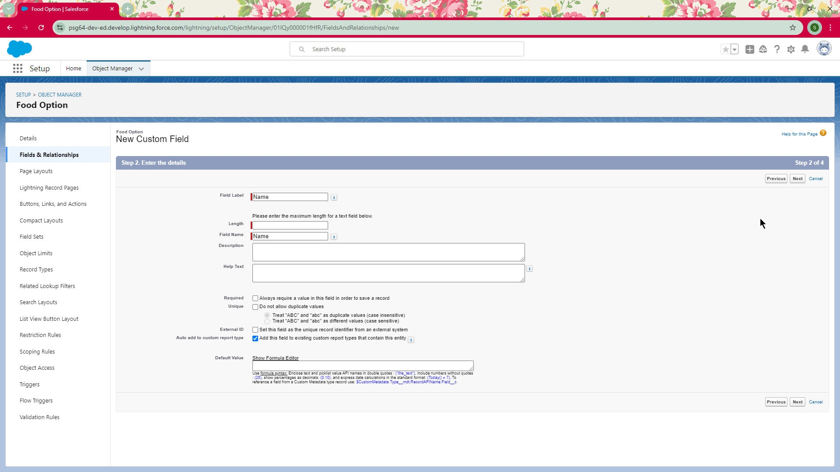

Creating field Name

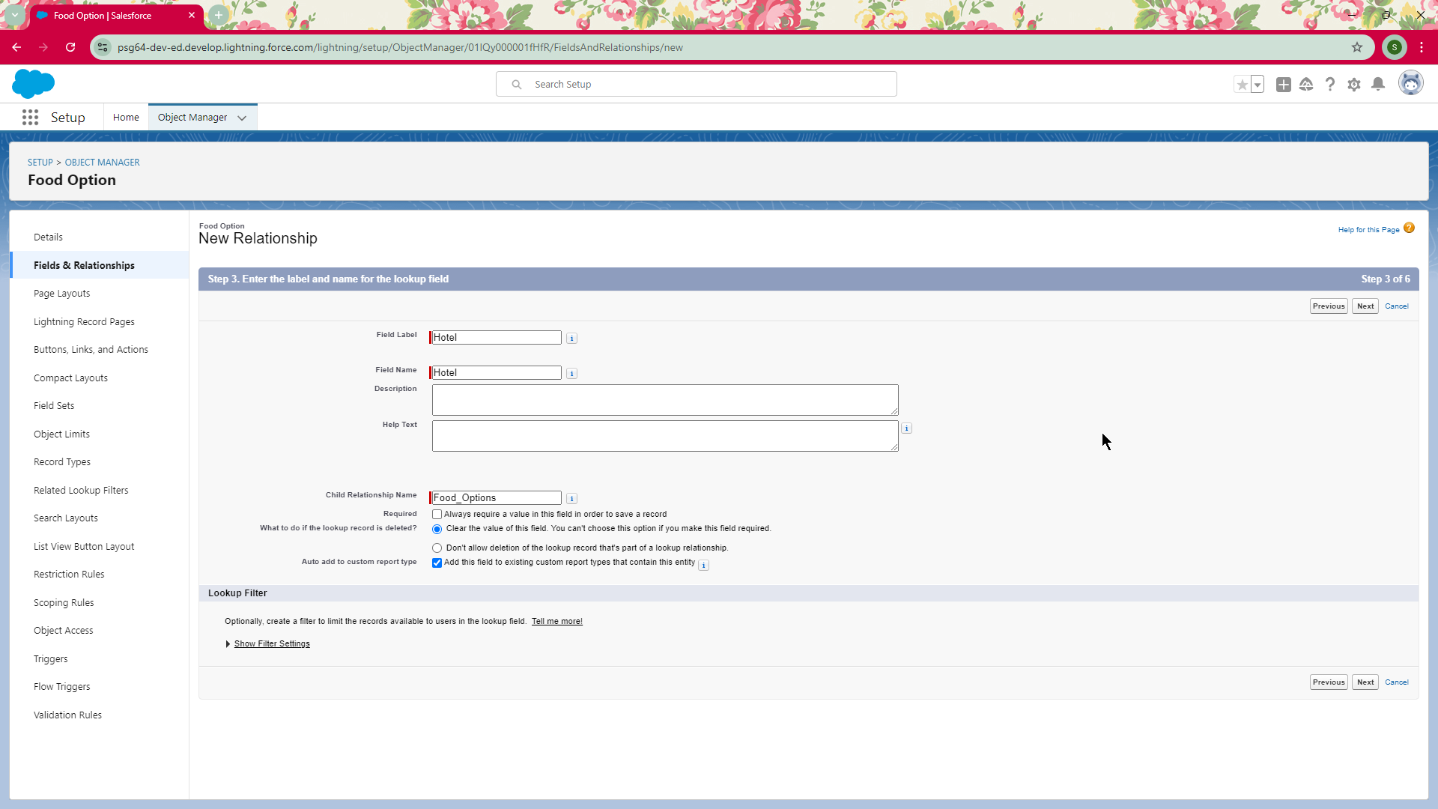

Creating field Hotel

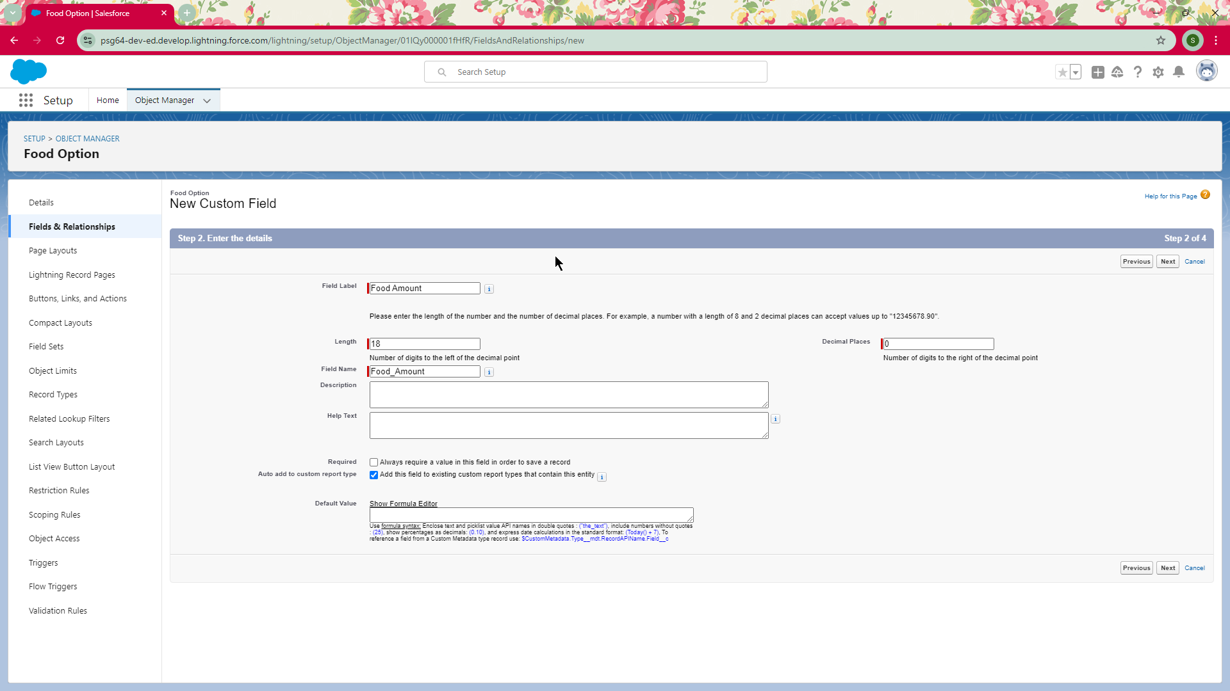

Creating field Food Amount

**Flight Object Fields:**

1. **Name (Text):** A name or code identifying the flight.
2. **DepartureDateTime (Date/Time):** The date and time of flight departure.

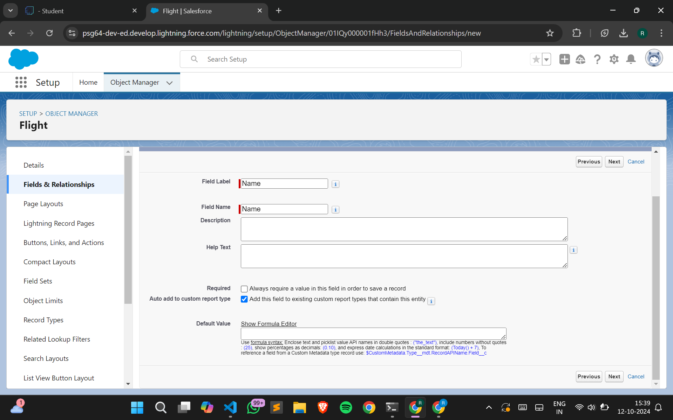

Creating field Name

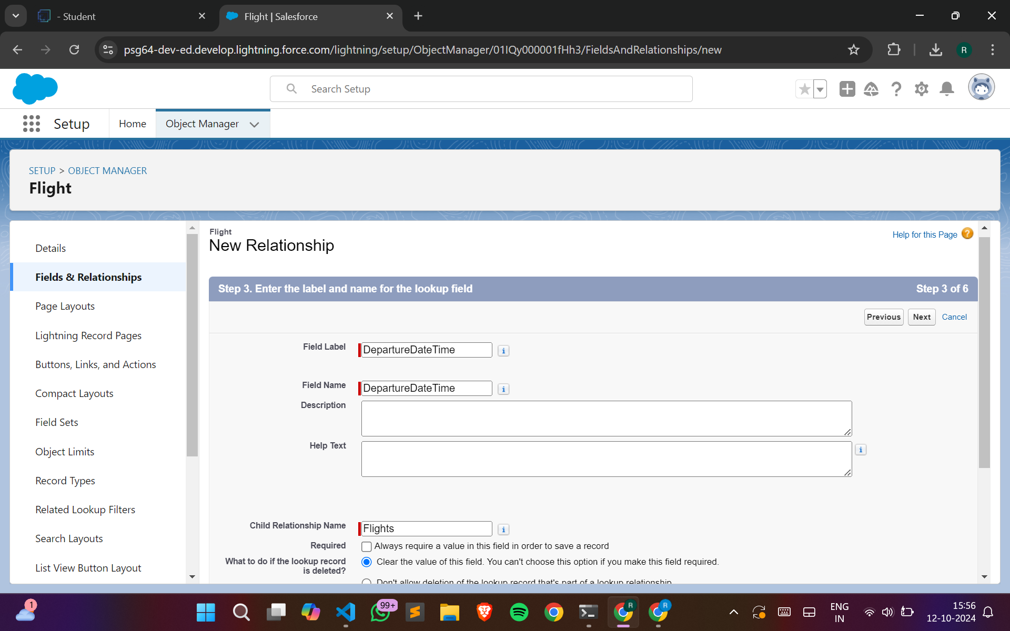

Creating field DepartureDateTime

**Customer Object Fields:**

1. **Customer Name (Text):** The name of the customer.
2. **Discount Amount (Formula - Currency):** A formula that calculates the discount based on customer criteria.
3. **Discount Percent (Percentage):** The percentage discount applied to the customer.

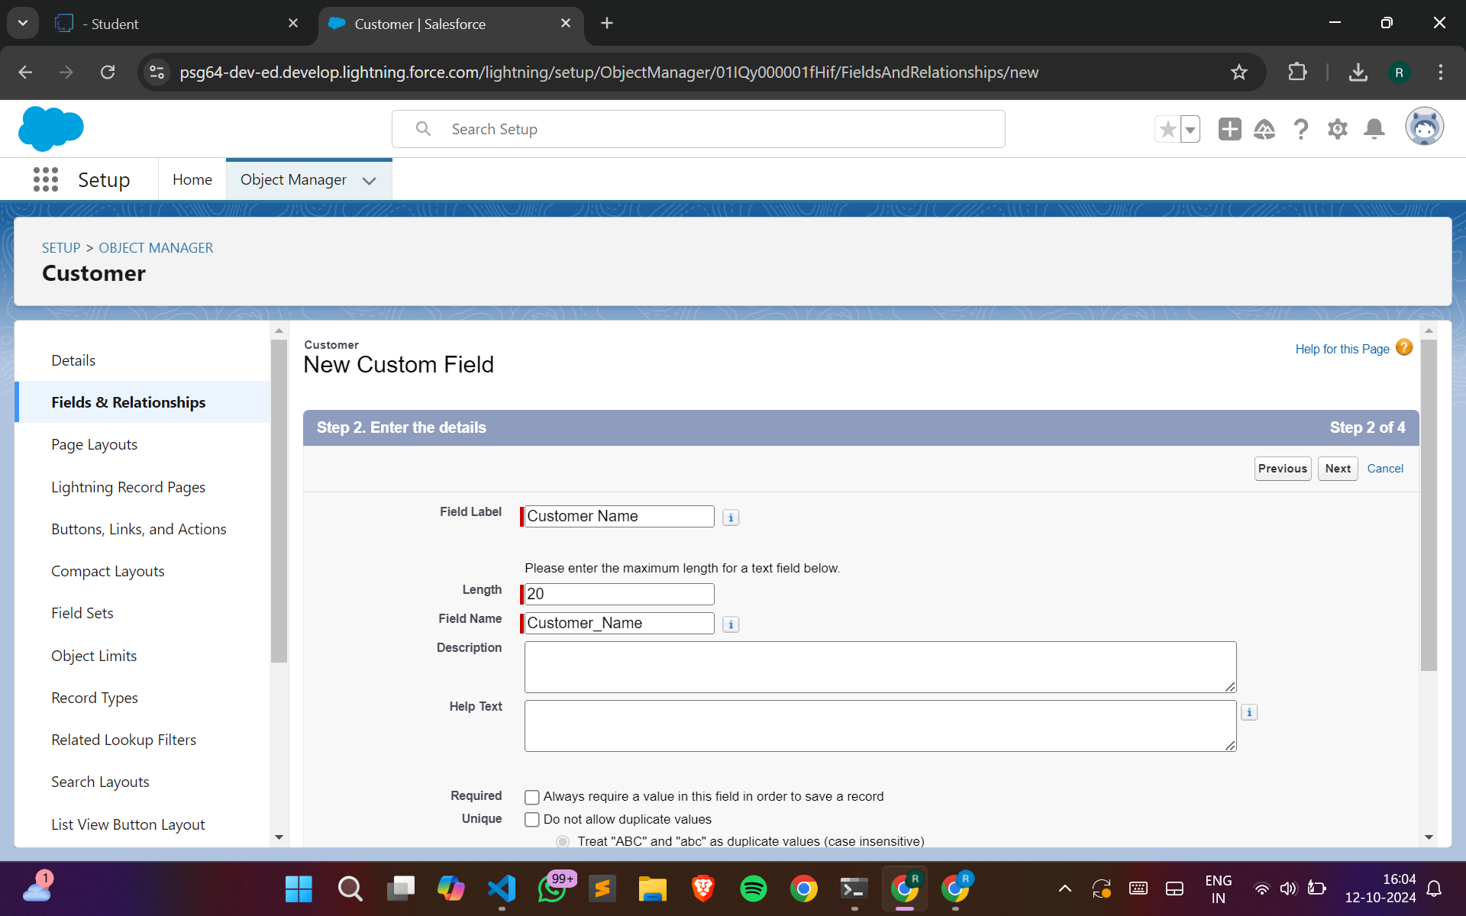

Creating field Customer Name

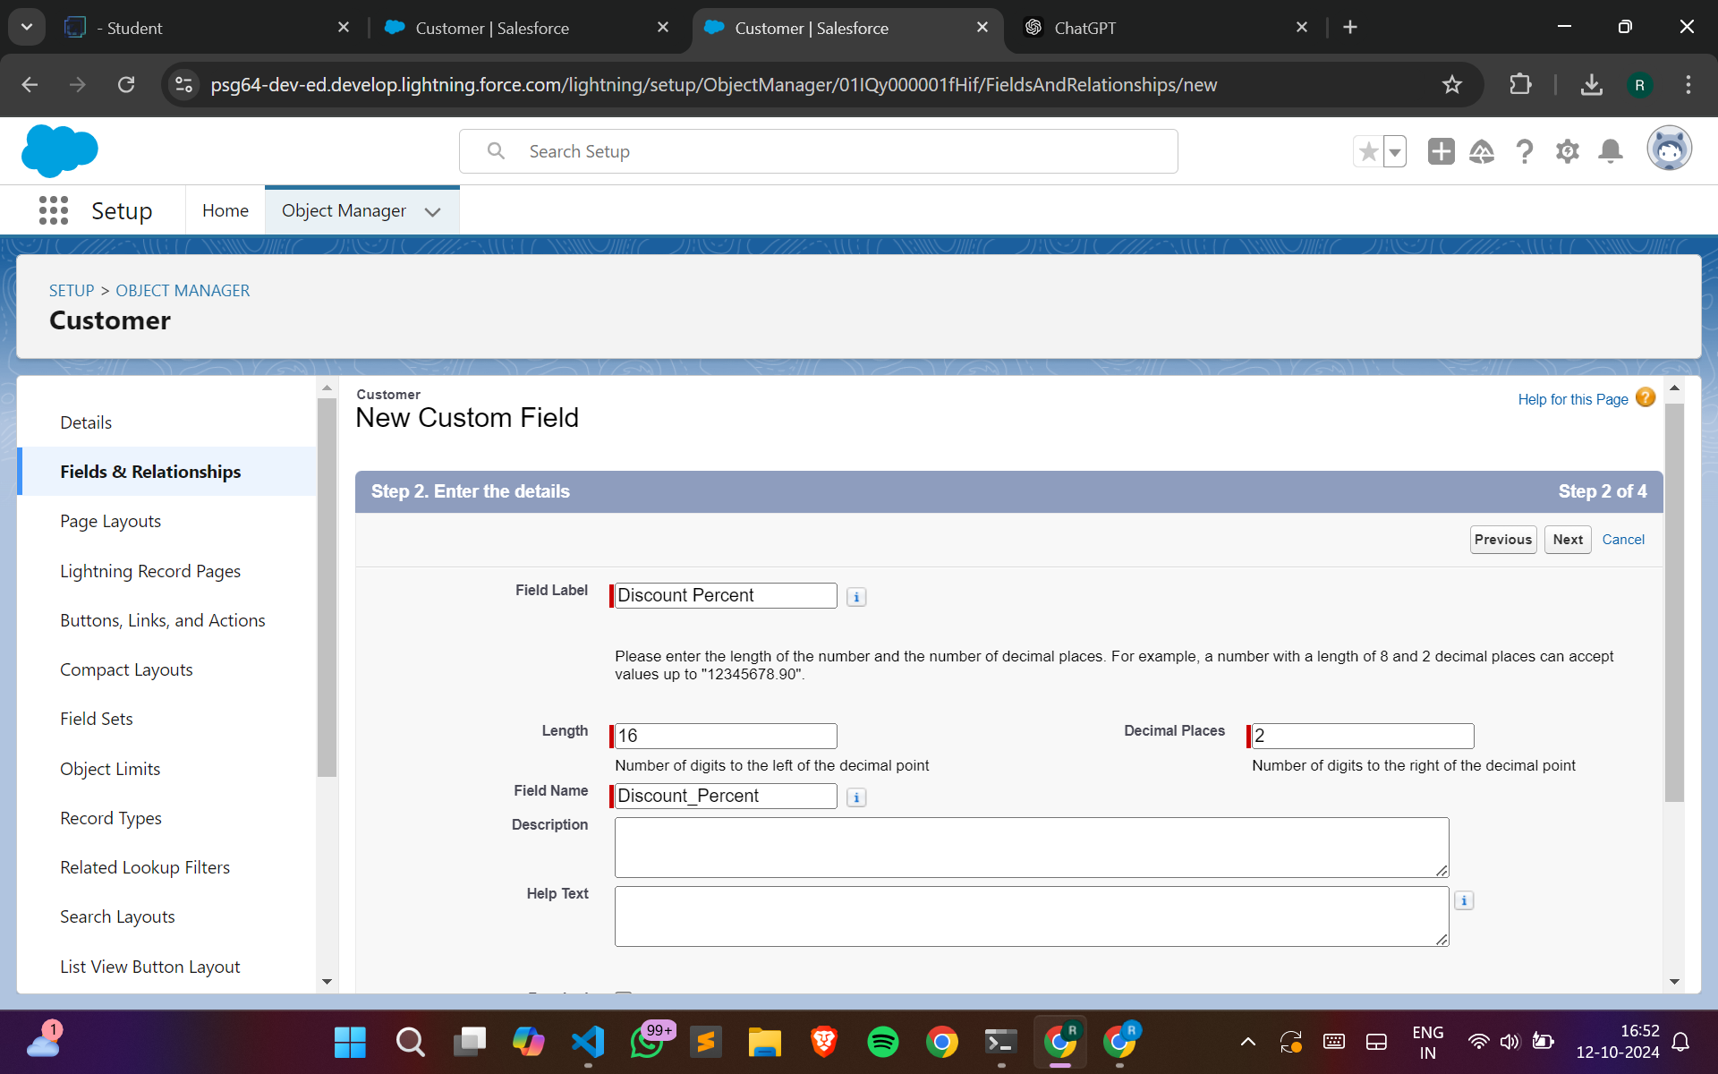

Creating field Discount Percent

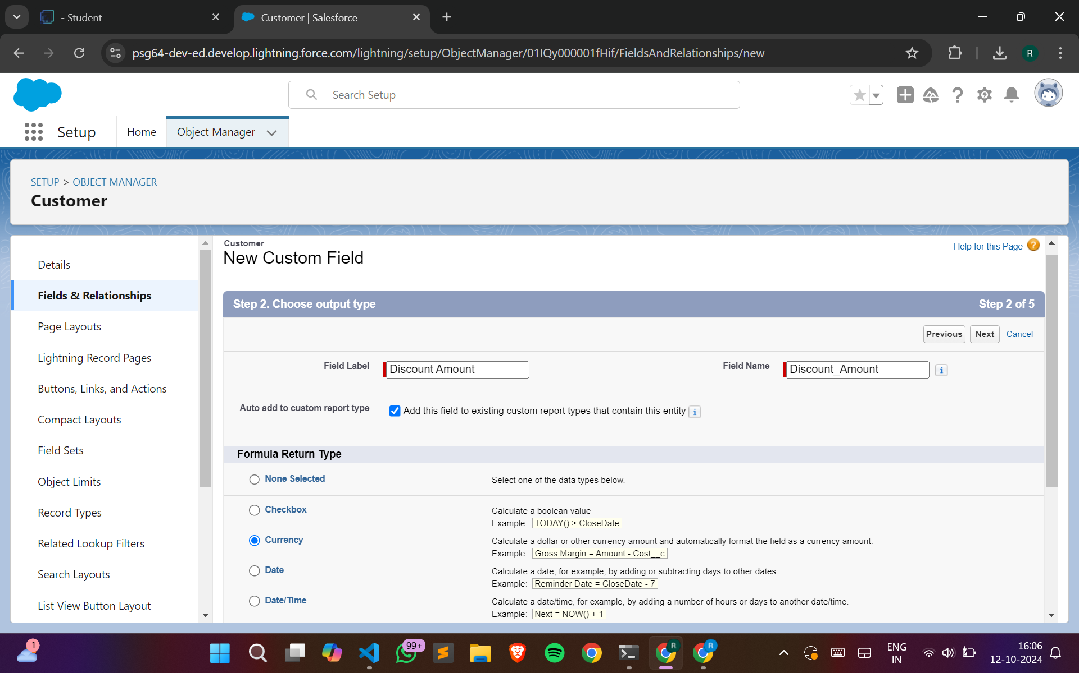

Creating field Discount Amount

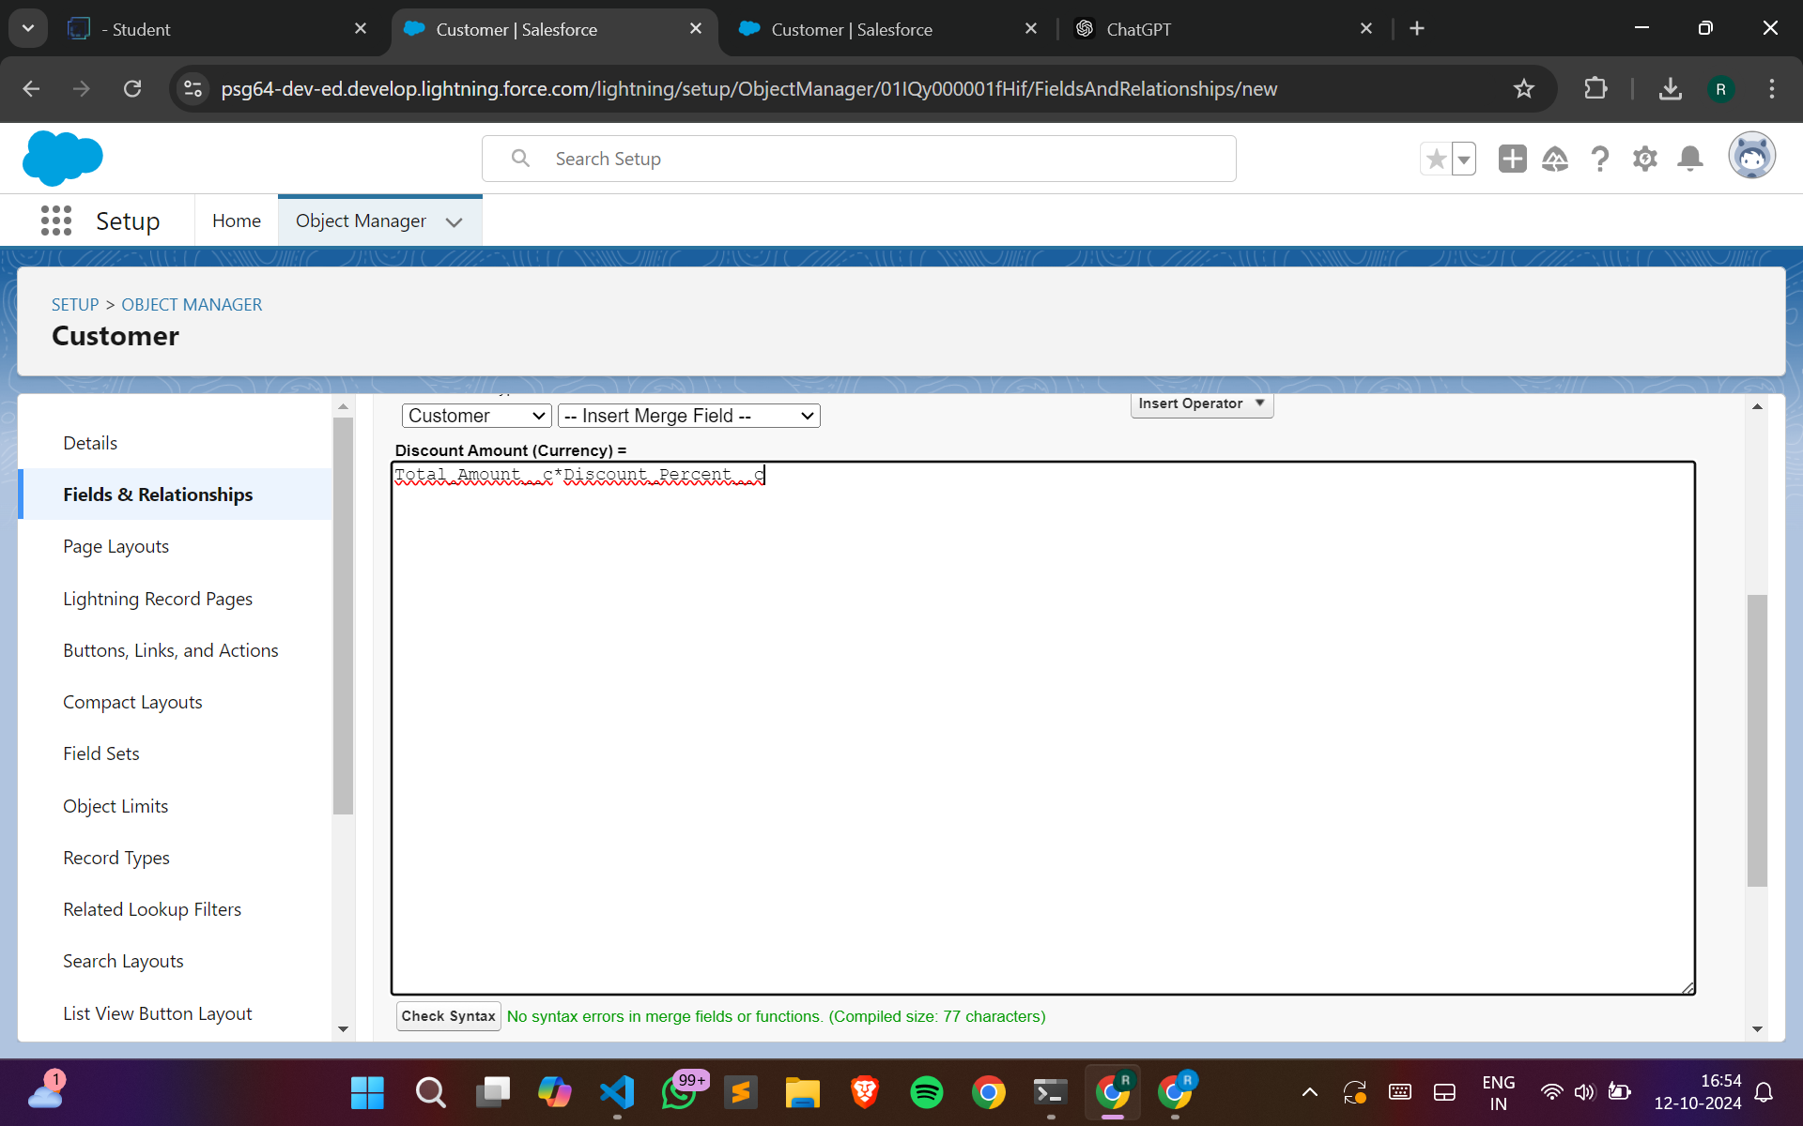

Creating field Discount Amount

#### Step 4: Create flow for Customer Discounts

* **Variables:**
  + **foId (Text) -** Available for Input
  + **csId (Text) -** Available for Input
  + **discount (Number)**
* **Flow Steps:**
  + **Get Records:** Retrieve customer data based on purchase histo**ry.**
  + **Decision Element: Add decision outcomes for different discou**nt thresholds:
    - **Full Discount:** For customers with amounts greater than 3000.
    - **Partial Discount:** For customers with amounts between 1500 and 3000.
    - **No Discount:** For customers below 1500.
  + **Assignments:** Assign appropriate discounts based on decisions made above.
* **Flow Outcome:**
  + Apply the correct discount to the customer’s account based on the flow's logic.

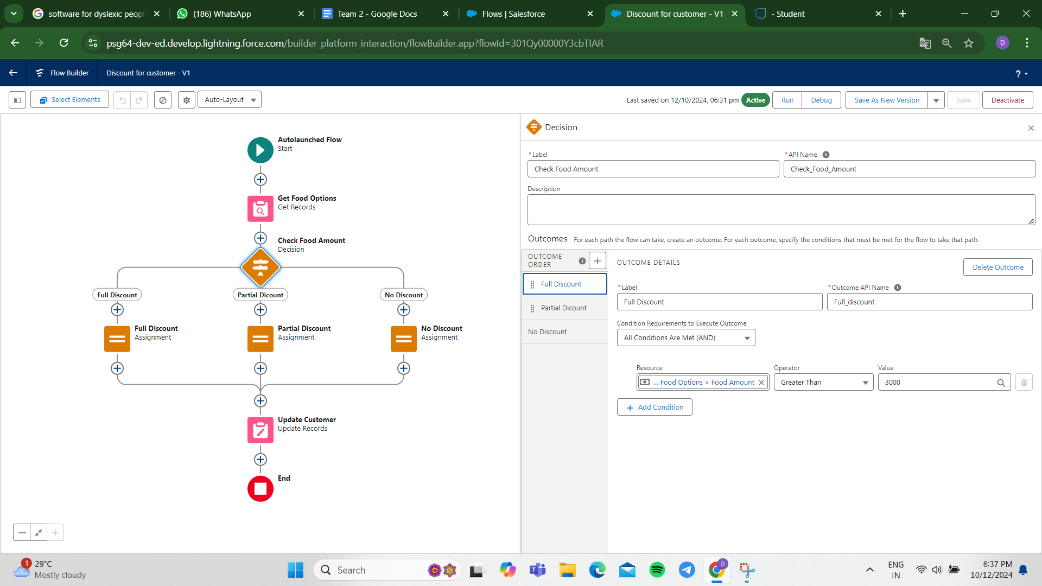

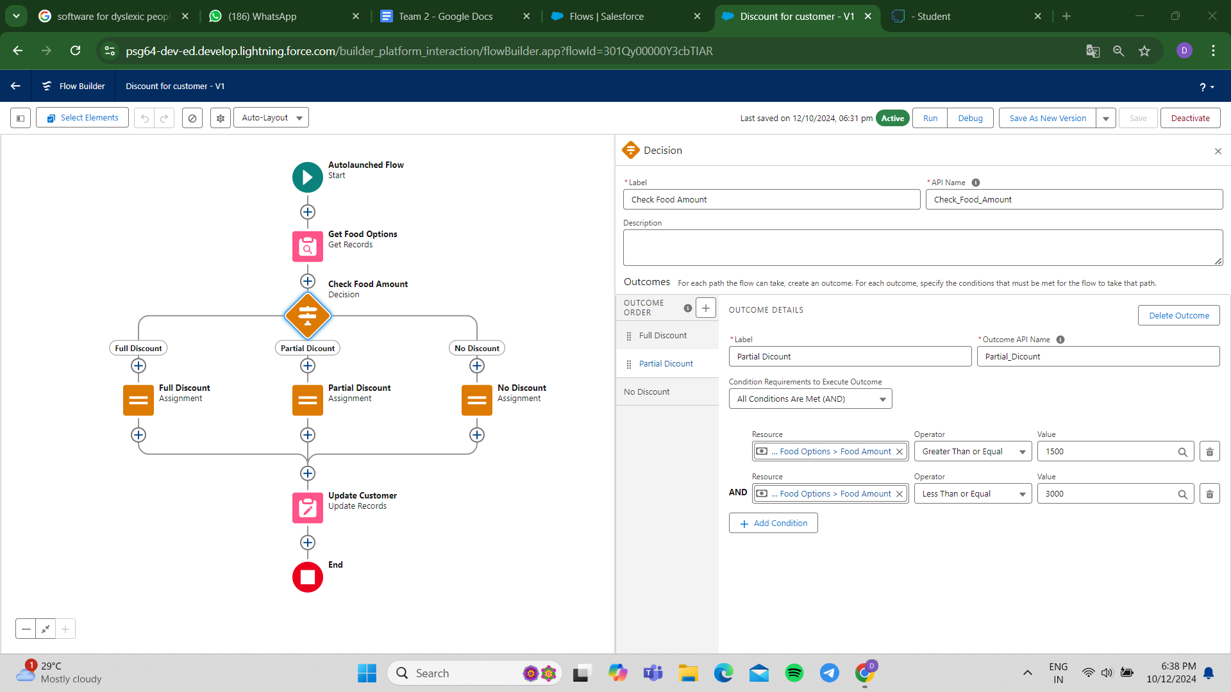

Condition for full discount and partial discount

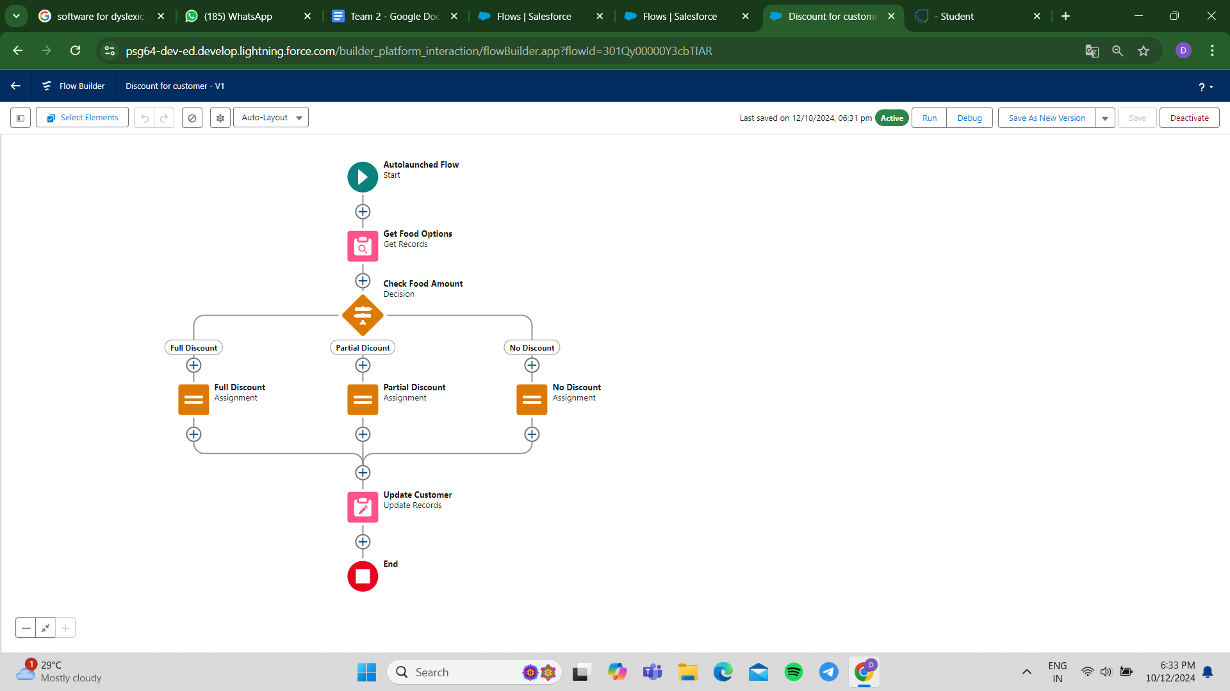

Flow created for discount approval

**Step 5: Apex Trigger and Handler for Updating Hotel Food Option Counts**

**Variables:**

* newFoodOptions (List of Food_Option__c) - List of new or updated food options passed to the handler.
* oldFoodOptions (List of Food_Option__c) - List of old food options (used only if required for comparisons).
* operation (TriggerOperation) - Type of trigger operation (e.g., insert, update, delete).
* hotelIdsToUpdate (Set of Id) - Set of unique Hotel IDs affected by the changes to the food options.
* hotelsToUpdate (List of Hotel__c) - List of hotel records that need to be updated.

**Apex Trigger Steps:**

1. Trigger Setup:

* Define a trigger on the Food_Option__c object.
* The trigger is set to run after insert, after update, and after delete to handle changes in food options.

1. Trigger Conditions:

* Check if the trigger is running after insert to ensure updates happen after new food options are created.

1. Call Handler Method:

* If the trigger is after insert, invoke updateHotelInformation from FoodOptionTriggerHandler to update hotel details based on the new food options.
* Pass trigger.new to the handler to retrieve the list of newly inserted food options.

**Apex Handler Steps (updateHotelInformation method):**

1. Collect Hotel IDs:

* Loop through each record in newFoodOptions.
* Add the Hotel__c (Hotel ID) from each food option to hotelIdsToUpdate to collect unique hotel IDs affected by the changes.

1. Retrieve Hotels to Update:

* Query the Hotel__c object for records with IDs in hotelIdsToUpdate.
* Retrieve fields Id, Name, and TotalFoodOptions__c to calculate and update the total food options for each hotel.

1. Recalculate Total Food Options:

* Loop through each hotel record in hotelsToUpdate.
* Run a query to count the total food options linked to each hotel using COUNT().
* Assign the result to the TotalFoodOptions__c field on the Hotel__c record.

1. Update Hotel Records:

* Perform an update on hotelsToUpdate to save the recalculated TotalFoodOptions__c values.

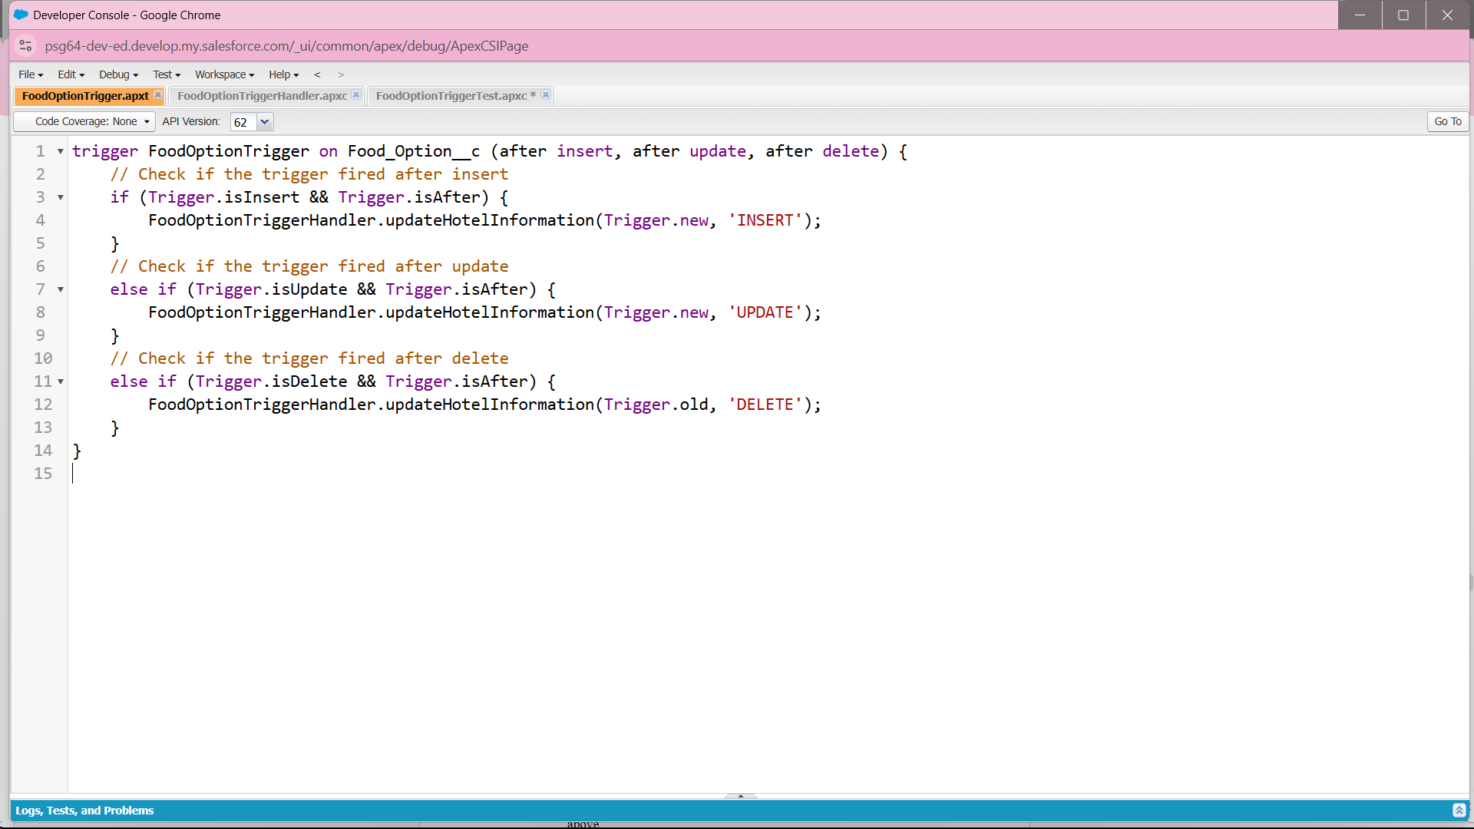

Trigger Code (FoodOptionTrigger)

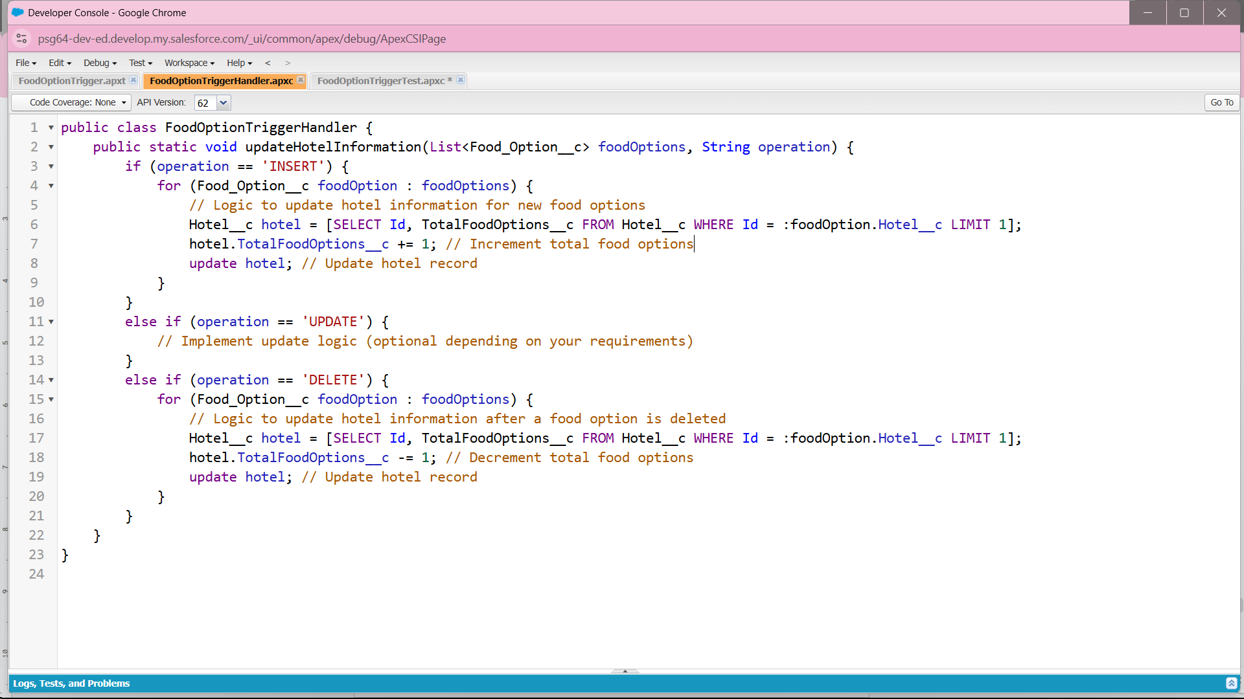

Handler Class Code (FoodOptionTriggerHandler)

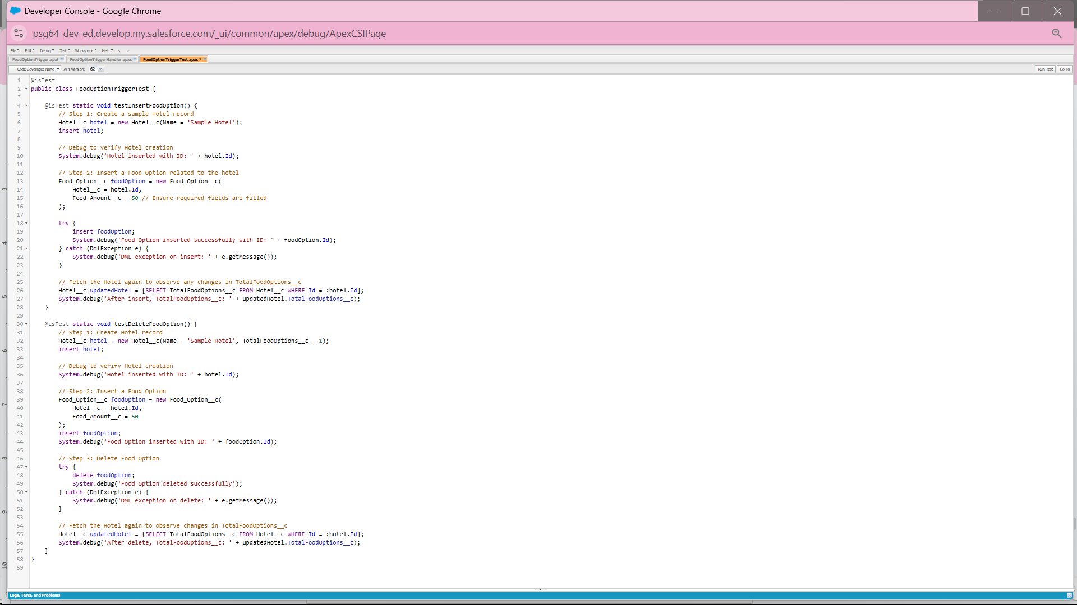

Test Code (FoodOptionTriggerTest)

**Step 6: Scheduled Apex Class for Automated Flight Reminder Emails**

**Variables:**

* DepartureDateTime__c (DateTime) - Custom field on the Flight__c object representing the flight's departure date and time.
* ContactEmail__c (Email) - Custom field on the Flight__c object holding the customer's contact email address for sending reminders.

**Apex Schedule Steps:**

1. Define Apex Schedule Class:

* Create a class named FlightReminderScheduledJob that implements the Schedulable interface, allowing it to be scheduled to run at specified times.

1. Schedulable Interface Implementation:

* Implement the execute method from the Schedulable interface.
* Inside execute, call the sendFlightReminders method to handle the logic for querying flights and sending reminders.

1. Query Upcoming Flights:

* In the sendFlightReminders method, query the Flight__c records where DepartureDateTime__c is within the next 24 hours (>= DateTime.now() and <= DateTime.now().addDays(1)).
* Retrieve fields Id, Name, DepartureDateTime__c, and ContactEmail__c.

1. Send Reminder Email:

* For each flight in upcomingFlights, create an email message using Messaging.SingleEmailMessage.
* Set the ToAddresses, Subject, and PlainTextBody of the email to include flight details and departure time.
* Send the email using Messaging.sendEmail().

**Anonymous Apex Code for Scheduling:**

1. Define Cron Expression:

* Set a cron expression to schedule the job daily at 6 AM.

1. Schedule the Job:

* Use System.schedule to run FlightReminderScheduledJob with the cron expression.

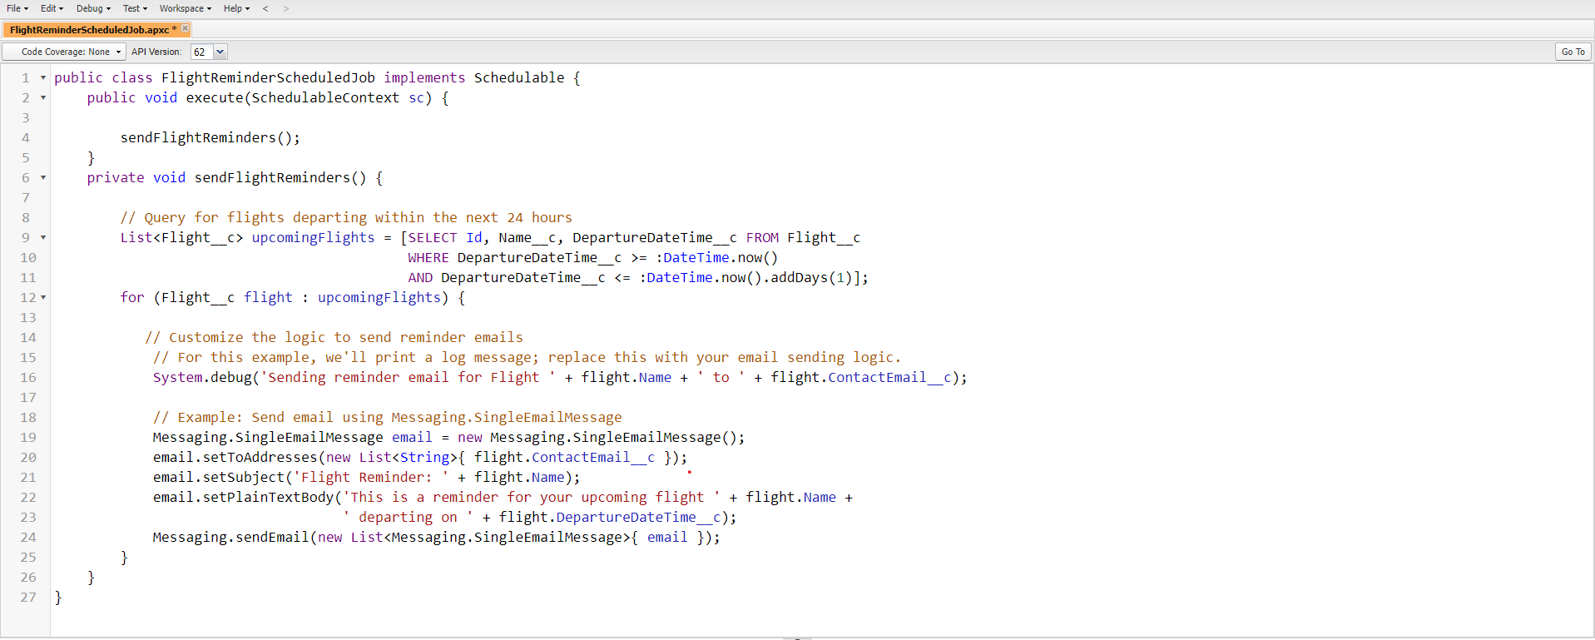

Flight Reminder Schedule Class Code

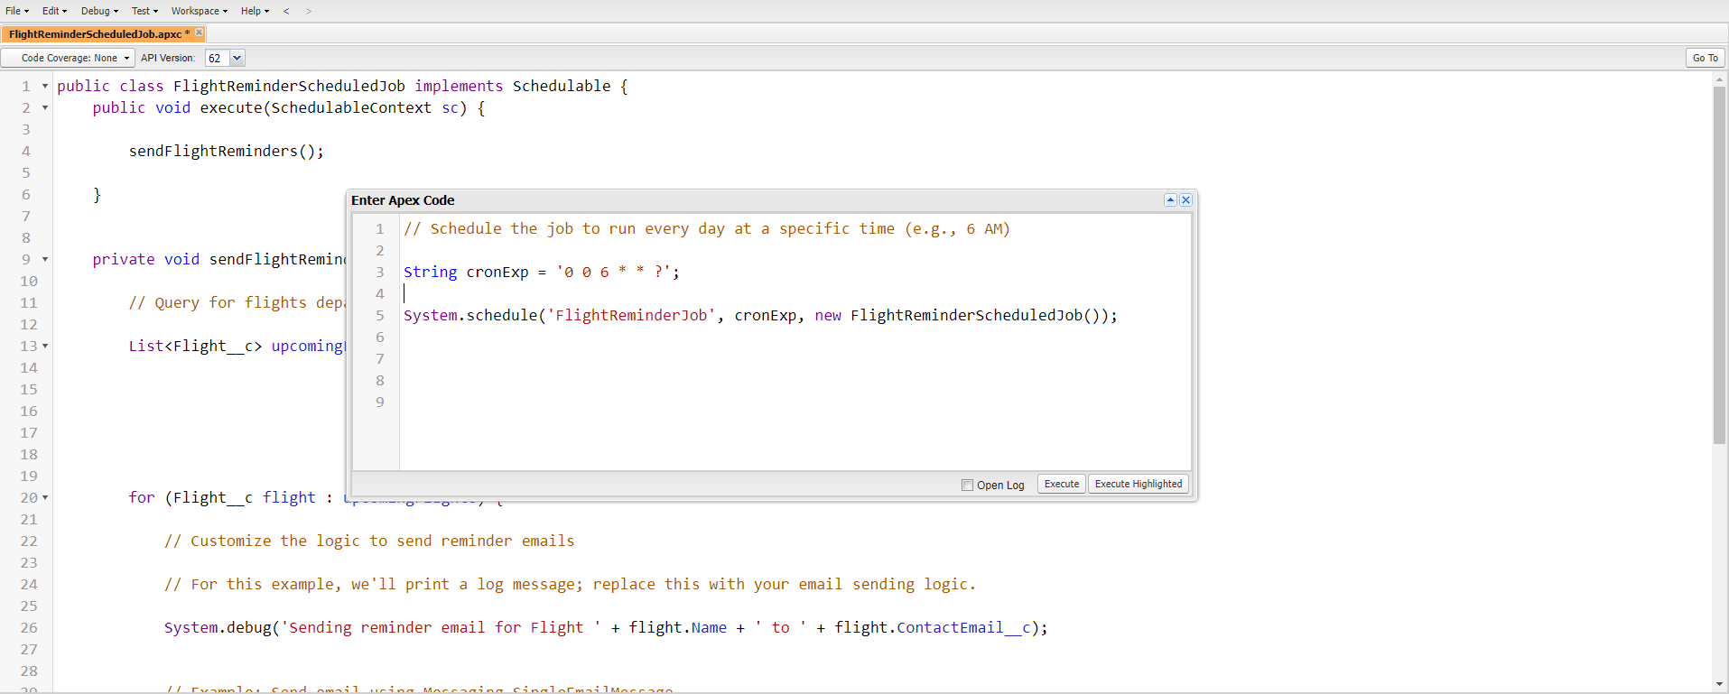

Scheduling Job to run at Specific Time

**5. Conclusion**

### Summary of Achievements:

The TripAdvisor E-Management Project successfully streamlined and automated various processes related to hotel management, flight bookings, food options, and customer notifications, significantly enhancing both operational workflows and the overall customer experience. Key accomplishments include:

* Optimized Operational Workflow: Implemented an integrated system for managing hotel requirements, food options, and flight bookings, ensuring seamless coordination and reducing the need for manual intervention in the TripAdvisor platform.
* Automated Customer Notifications: Developed a schedulable Apex class to send timely flight reminders to customers 24 hours before departure, improving customer service by ensuring customers are well-informed and prepared for their travels.
* Real-Time Data Synchronization: Designed and deployed Apex triggers and flows to automatically update and synchronize hotel and food option data in real-time, ensuring that customers have access to accurate and up-to-date information.
* Dynamic Discount Allocation: Created automated processes to apply personalized discounts for customers based on their purchasing behavior, offering a tailored experience that enhances customer satisfaction and loyalty.
* Improved Efficiency and Customer Experience: Leveraged Salesforce’s automation tools to reduce manual processes, allowing for quicker updates, more accurate data, and a smoother experience for customers booking hotels, flights, and food options.

This project demonstrates how Salesforce automation can effectively improve the efficiency of business operations and enhance the customer experience in the travel and hospitality industry, particularly for platforms like TripAdvisor. By integrating key processes into a single, automated system, the project helps streamline workflows, reduce manual effort, and provide a superior service to customers.